Virtual Master Bot

Abidjan,Plateau,

Abidjan,

+(225) 08175631

info@robotspacebin.com

PROCESS DEFINITION DOCUMENT

RobotSpareBin Inc

Weekly sales report creation

## DOCUMENT VERSION HISTORY

|  |  |  |
| --- | --- | --- |
| **Version** | **Author** | **Date** |
| 1.0.0 | TOURE SOULEYMANE | 19/01/21 |

## 

## SIGNED OFF BY

|  |  |  |
| --- | --- | --- |
| **Name** | **Function** | **Responsibility** |
| Maria | Admin of the intranet | Process Owner |
| TOURE SOULEYMANE | Developer | Developer |

## 

## CONTRIBUTORS

|  |  |  |
| --- | --- | --- |
| **Name** | **Function** | **Responsibility** |
| Maria | Admin of the intranet | Process Owner |
| TOURE SOULEYMANE | DEVELOPER | DEVELOPER |

# 

# Current process analysis

# High level description

The process is used to report the weekly sales

Maria's copypaste weekly task consist to :

## She goes to the intranet at https://robotsparebinindustries.com/,

## Logs in

## Adding the data for the week for each sales representative

## Firstname,

## Lastname,

## The value of sales for the week,

## weekly target

## After entered all the data :

## she takes a screenshot of the page

## adds it to the weekly newsletter and Sends out this newsletter to everyone

## Systems involved

|  |  |  |
| --- | --- | --- |
| **System** | **Used for** | **User role needed** |
| **Web application** | Used to collect and extract data into excel file | Admin |
| Excel | Copy the data and past it then send feedback email |  |

## 

## Process flow

A good flowchart is worth a thousand words! You can brush up on the (few) rules needed to make a good flowchart [here](https://en.wikipedia.org/wiki/Flowchart), and then get charting!

Here is a description of the process in the form of a flow chart:

Here’s what a very simple flowchart could look like:

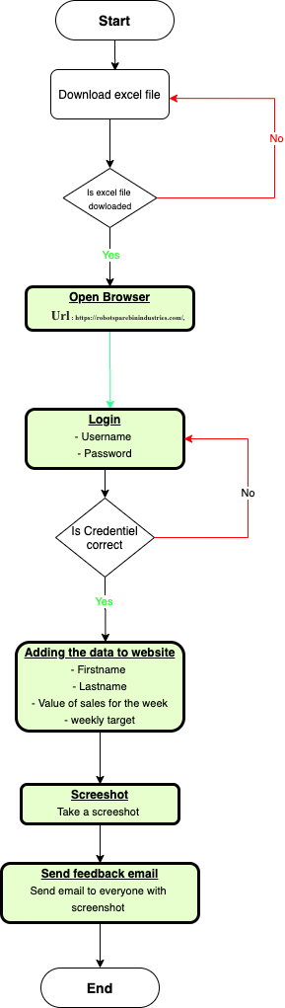

## Detailed steps

Now it’s time to get into the details! **Break down the process into all its steps**, and for each one provide all the information needed. Try to imagine that you are explaining this to someone that knows nothing about the process. They should be able to complete the process on their own after they have read your clear instructions!

### <Descriptive name of step 1>

A good name for a step for example is in the format “<operator> <action> <object of the action>”. For example: **“The employee clicks the button "Add to Cart" next to the product. The product is added to the shopping cart".** This is not a hard rule though.

In the description of each step you are free to add anything that you think will help explain it better. Screenshots of the user interface, schema of the data involved, etc.

<Description of the step>

### <Descriptive name of step 2>

<Description of the step>

## Possible exceptions

This part is **really really important**: so far you have been describing an ideal case, where the operator has all the data they need, all systems work perfectly together and everybody is happy. But, there are times where the process does not run that smoothly for various reasons: we call these cases “**Exceptions**”.

Exceptions are special cases and rules that can influence and even stop the smooth running of the process.

### Logic Exceptions

Logic exceptions happen when something is wrong with the information that is being processed. For example, if an order has incomplete data, the operation has to stop. Or maybe the business has certain rules that it has decided on and the operator knows about: “do not sell more than 10 pieces a day for that product”. These need to be written down here carefully, because the robot will have to follow the same rules.

#### <Logic exception1>

<Description of logic exception1>

...

### System Exceptions

Software can have bugs, network connections can fail, passwords can no longer be valid: in all these cases we say that a **system exception** has happened. Write down all these possible cases, explaining what the operator sees, and also if there are ways to get around them.

#### <System exception1>

<Description of system exception1>

…

**And you are done**! Best of luck for your RPA project!